**DATA Tables of DataBase Travel**

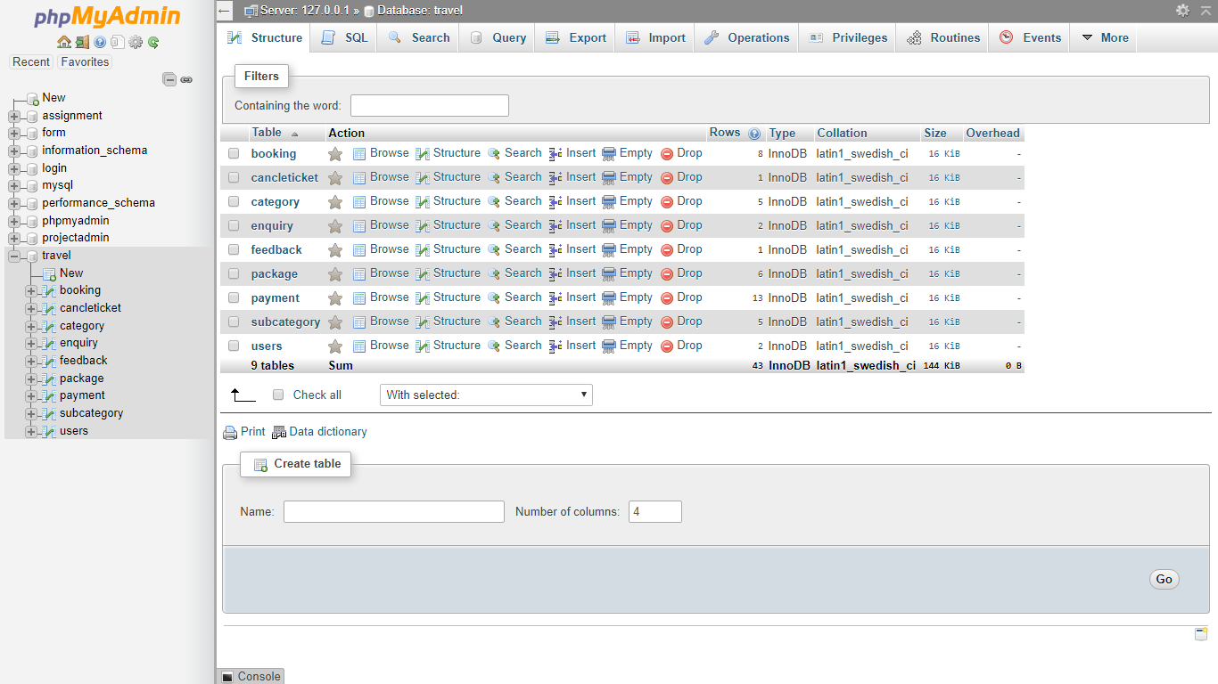

**Table: 1.Booking**

**In this table the primary key is Email-id.**

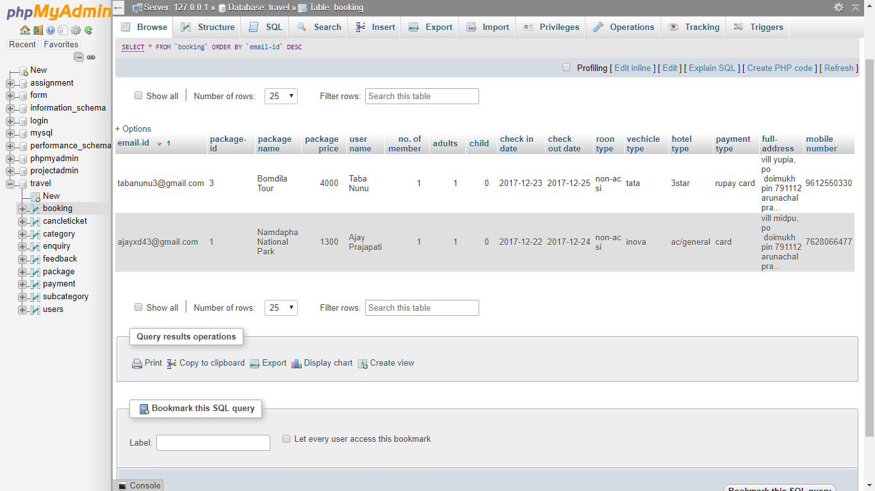

**Table: 2.Cancelticket**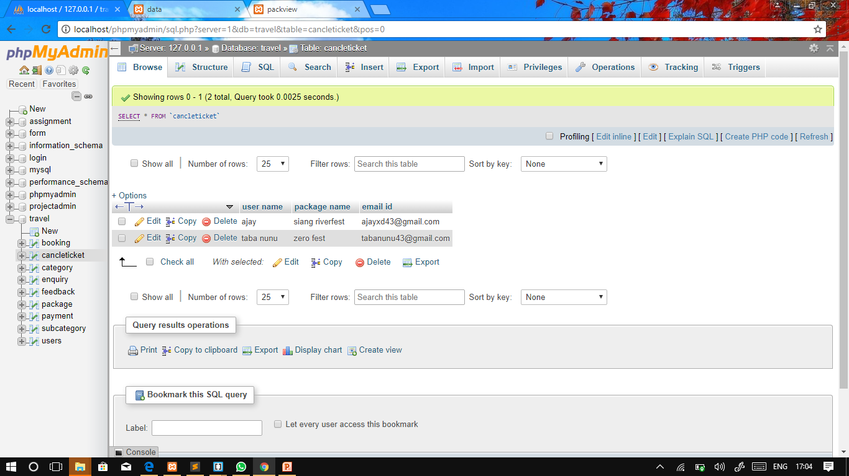

**Table: 3.Category**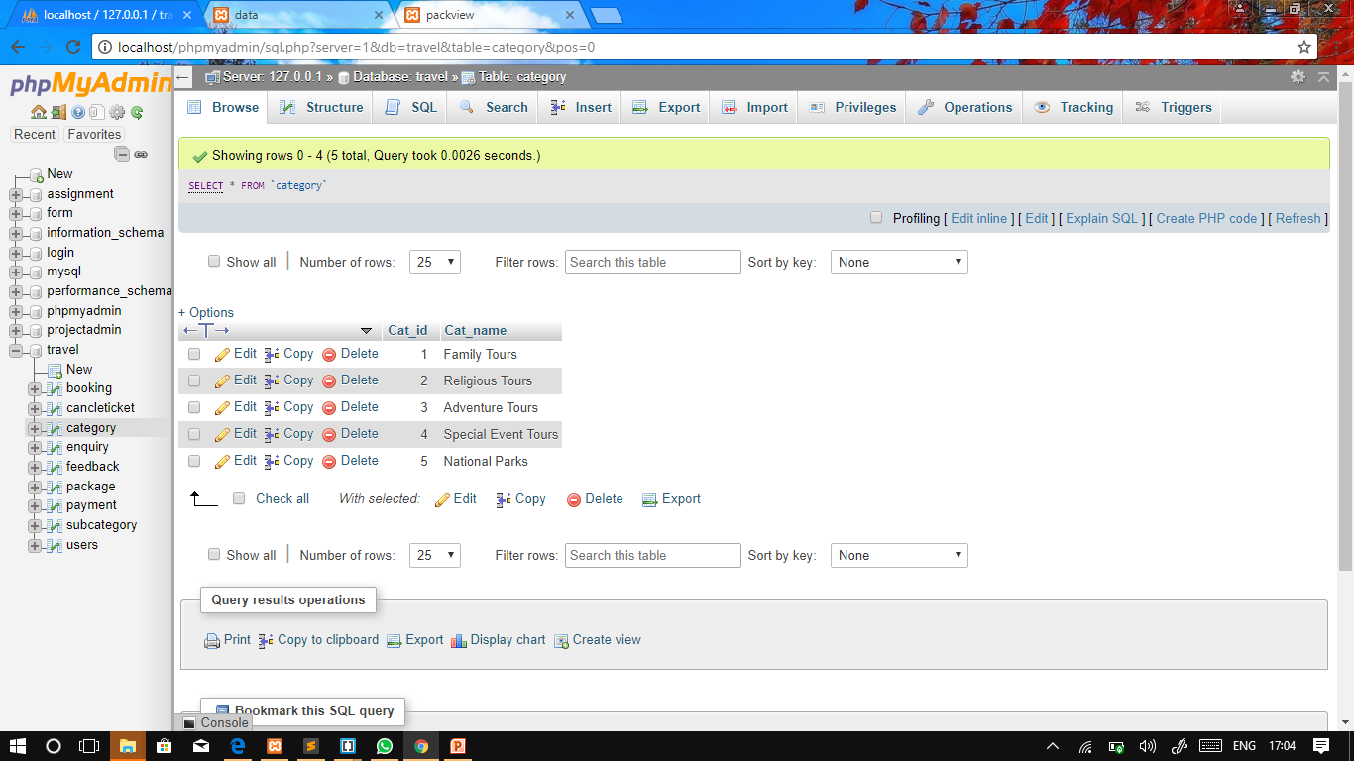

**Table: 4.Enquiry** 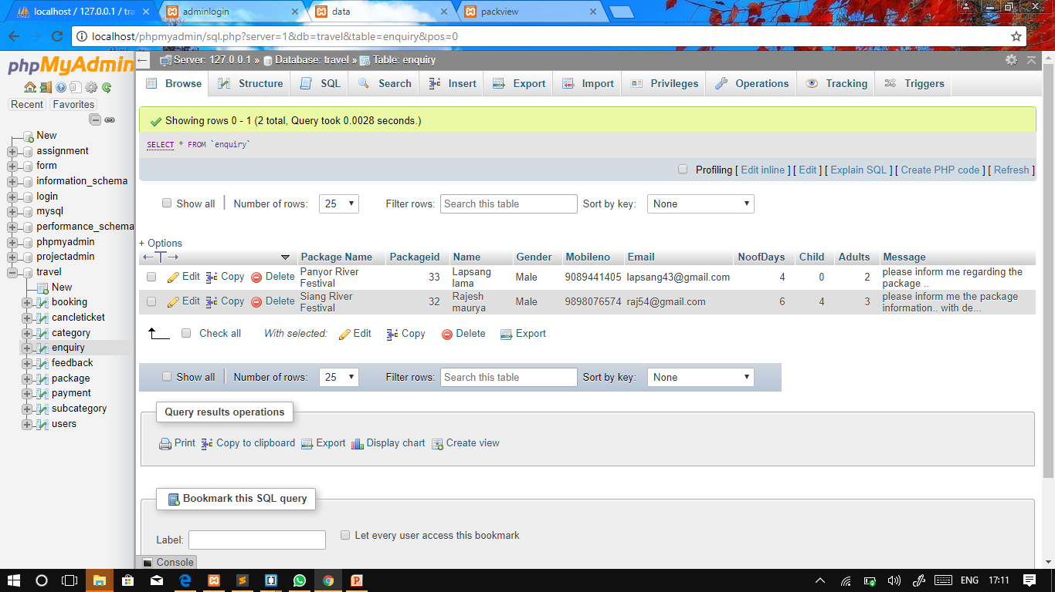

**Table: 5.Feedback**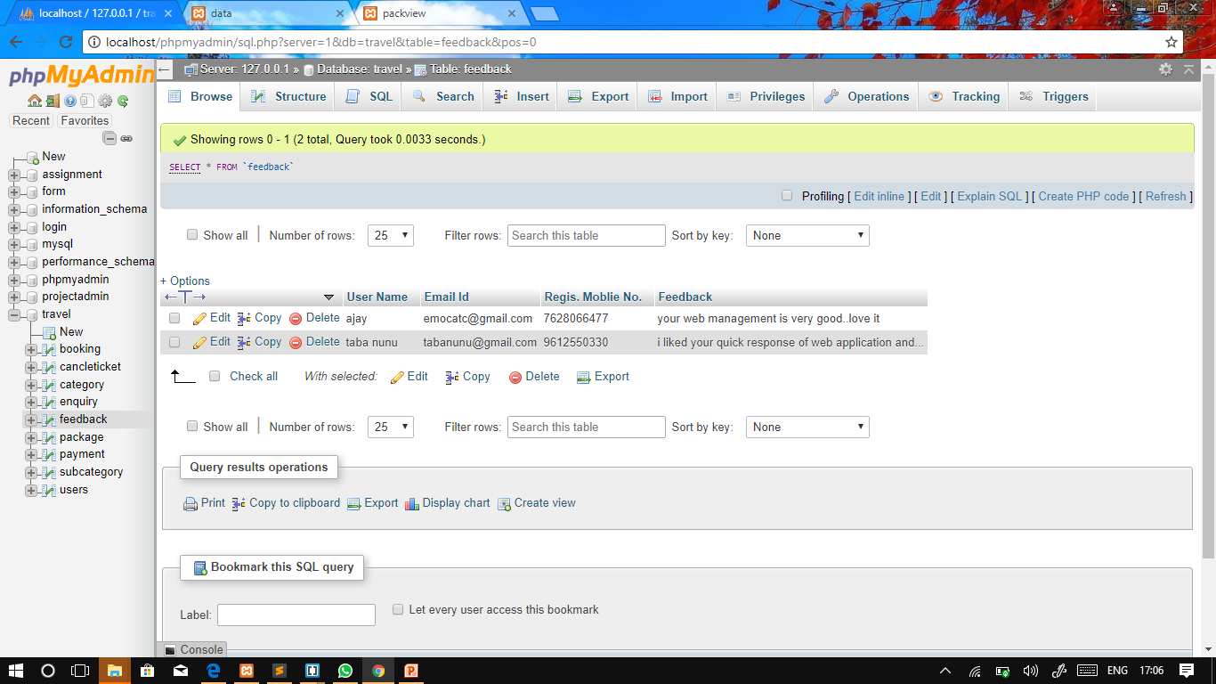

**Table: 6.Package**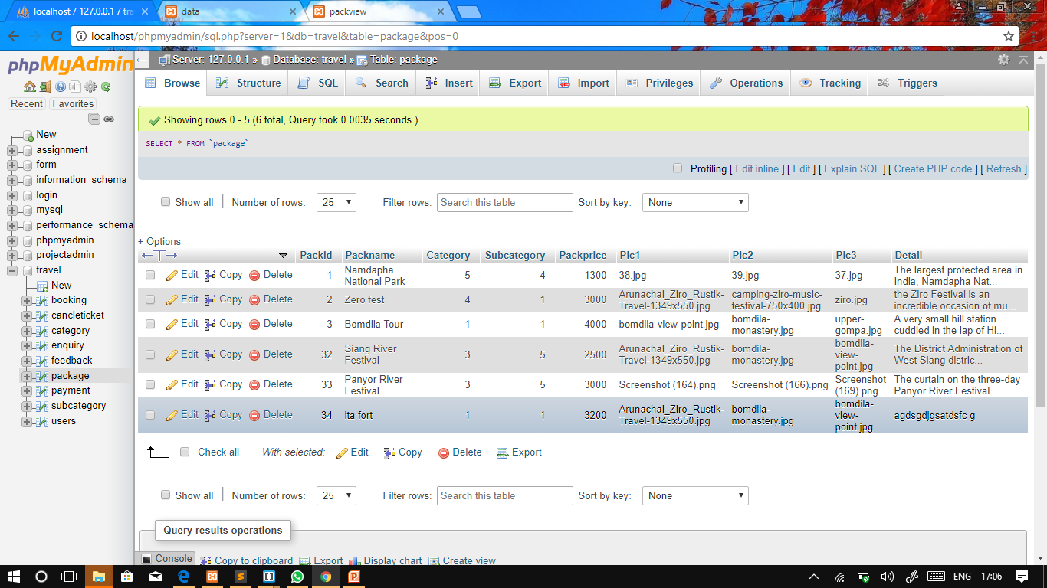

**Table: 7. Subcategory**

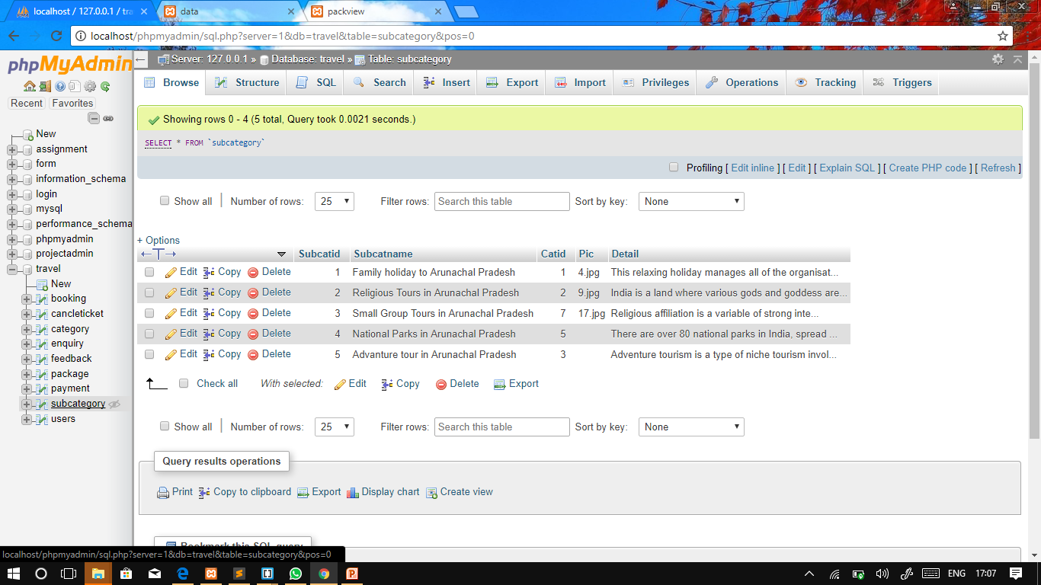

**Table: 8. Users**

**In this table the primary key is type-of-user.**

